CS 255 System Design Document Template

UML Diagrams

UML Use Case Diagram

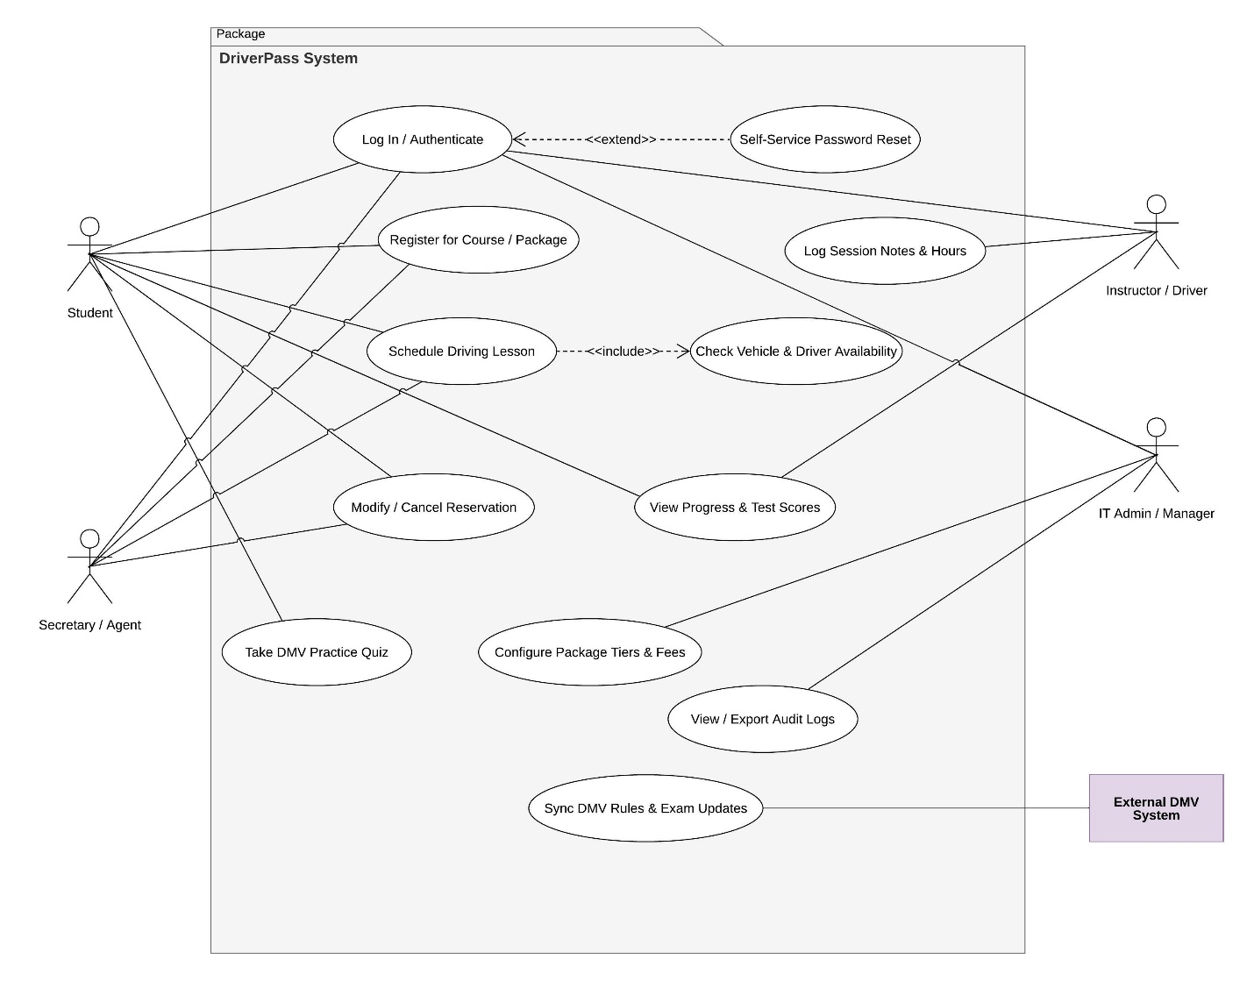

UML Activity Diagrams

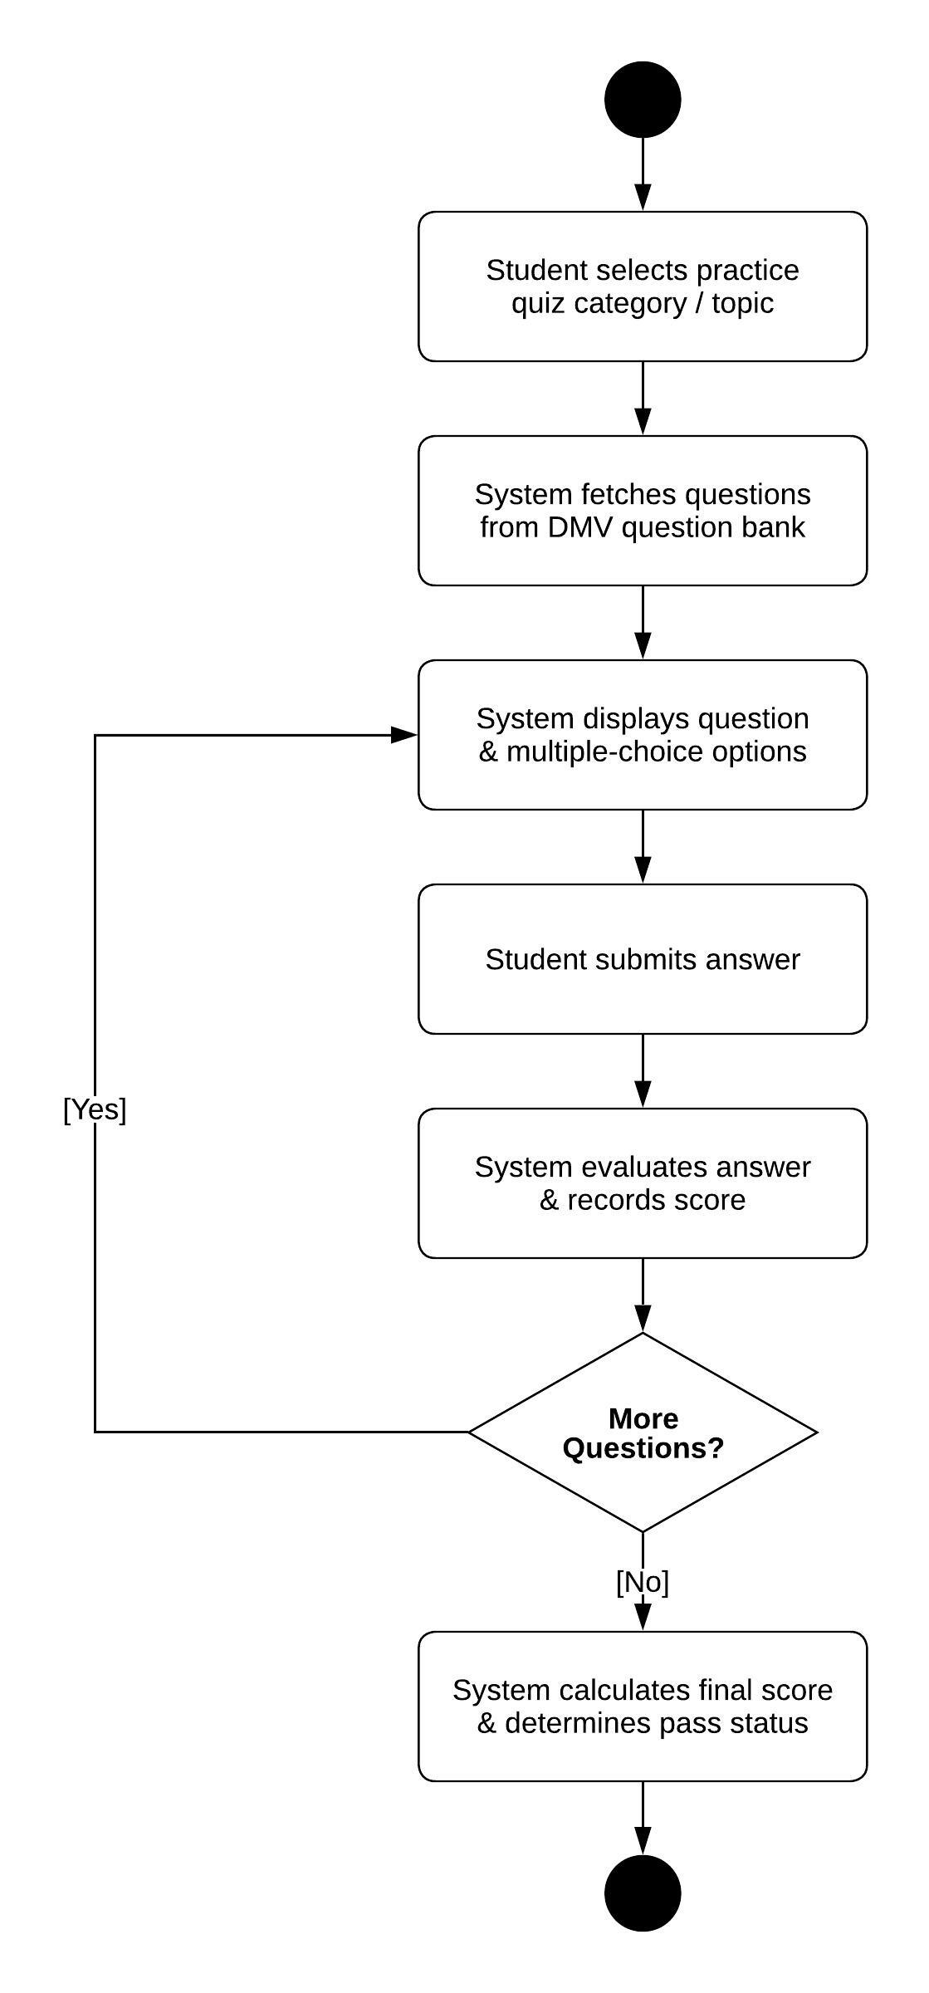
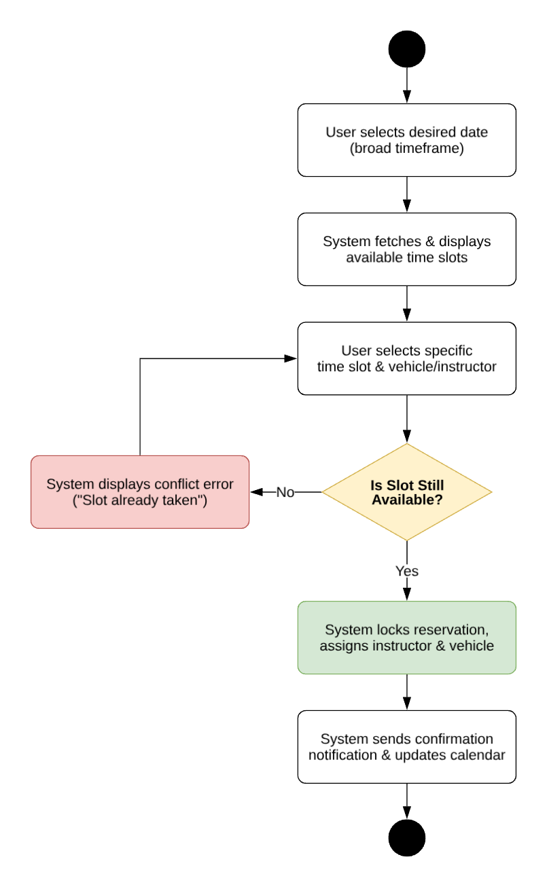

UML Sequence Diagram
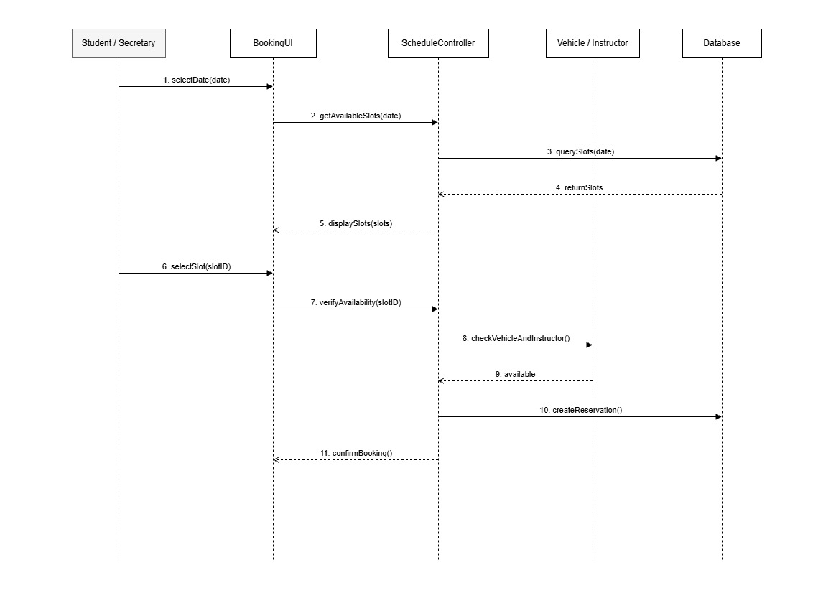

UML Class Diagram
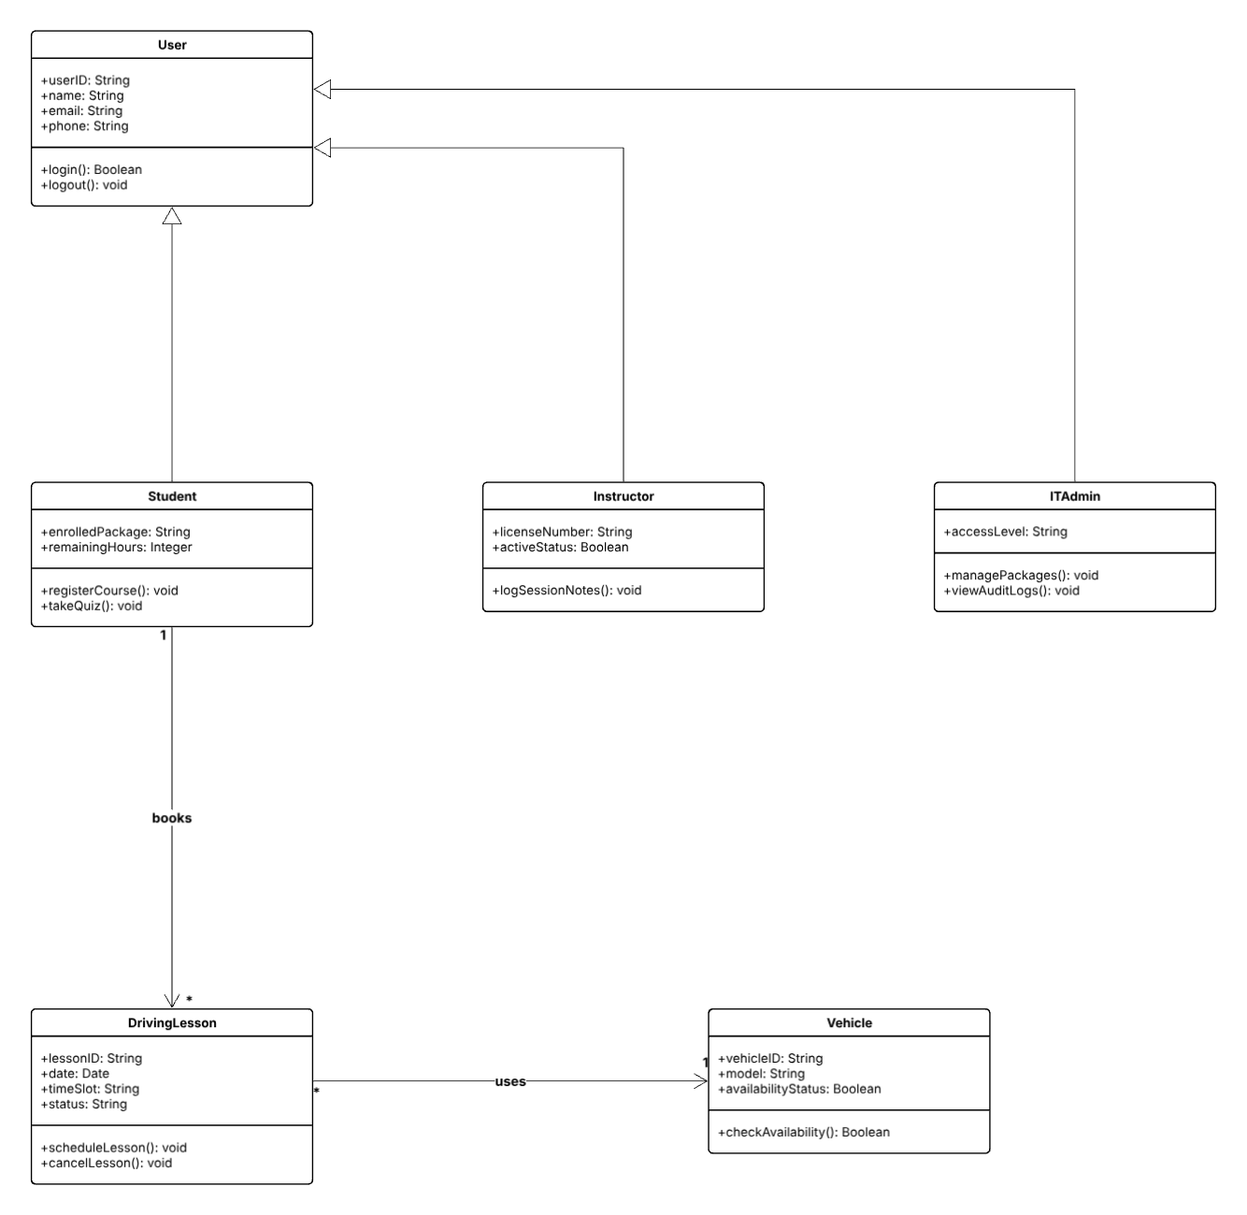

Technical Requirements

Hardware Requirements
- Server & Cloud Hosting Hardware:
  - Virtual Private Server (VPS) / Cloud Instance: Minimum 2 vCPUs, 4 GB RAM, and 50 GB SSD storage to ensure low-latency handling of concurrent user requests (students booking slots, secretaries managing the master calendar).
  - Scalability: The cloud instance must support horizontal scaling or tier upgrades should user registration and quiz volume grow.
- Client-End Hardware (End Users & Staff):
  - Student / Instructor Devices: Smartphones, tablets, or desktop computers with internet connectivity to access the web/mobile portal for lesson booking and practice quizzes.
  - Administrative / Secretary Workstations: Standard desktop or laptop computers equipped with modern web browsers (Chrome, Firefox, Safari, Edge) for handling phone reservations, walk-ins, and master scheduling.

Software & Operating Systems
- Server Operating System:
  - Ubuntu Server (Long Term Support - LTS) or equivalent enterprise Linux distribution for stable, secure backend execution.
- Database Management System (DBMS):
  - Relational Database Management System (such as PostgreSQL or MySQL) to maintain ACID compliance for transactional data (student packages, remaining lesson hours, vehicle availability, and booking logs).
- Application Runtime & Frameworks:
  - Backend Runtime: Node.js or Python (Django/Flask) to handle routing, authentication, business logic validation, and API endpoints.
  - Frontend Framework: Responsive web framework (such as React or HTML5/CSS3/JavaScript) to support dynamic user interfaces across desktop and mobile screens.

Infrastructure & Network Architecture
- Cloud Infrastructure Provider:
  - Cloud-hosted environment (such as AWS, Oracle Cloud Infrastructure, or DigitalOcean) ensuring 99.9% uptime and remote accessibility for both students and staff.
- Network & Security Protocols:
  - Transport Layer Security (TLS/HTTPS): Mandatory encryption for all client-server communication to protect sensitive user credentials and personal data in transit.
  - Role-Based Access Control (RBAC): Software-level infrastructure enforcing strict authorization boundaries (e.g., Students can only view their own bookings/quizzes, while IT Admins and Secretaries have overarching schedule management permissions).
  - Database Encryption: Storage-level encryption (at rest) for sensitive user information, contact details, and progress records.
- Backup & Disaster Recovery:
  - Automated daily database snapshots and incremental backups stored in a geographically isolated bucket to ensure rapid recovery in case of system failures.

Development, Design & Management Tools
- Version Control: Git and GitHub for collaborative source code management, branch tracking, and code reviews among development team members.
- Testing Tools: Automated testing frameworks for unit and integration testing of the booking validation and quiz evaluation logic.

